SIMATS ENGIN EERING
SAVEETHA INSTITUTE OF MEDICAL AND TECHNICAL SCIENCES

EXPERIMENT 01
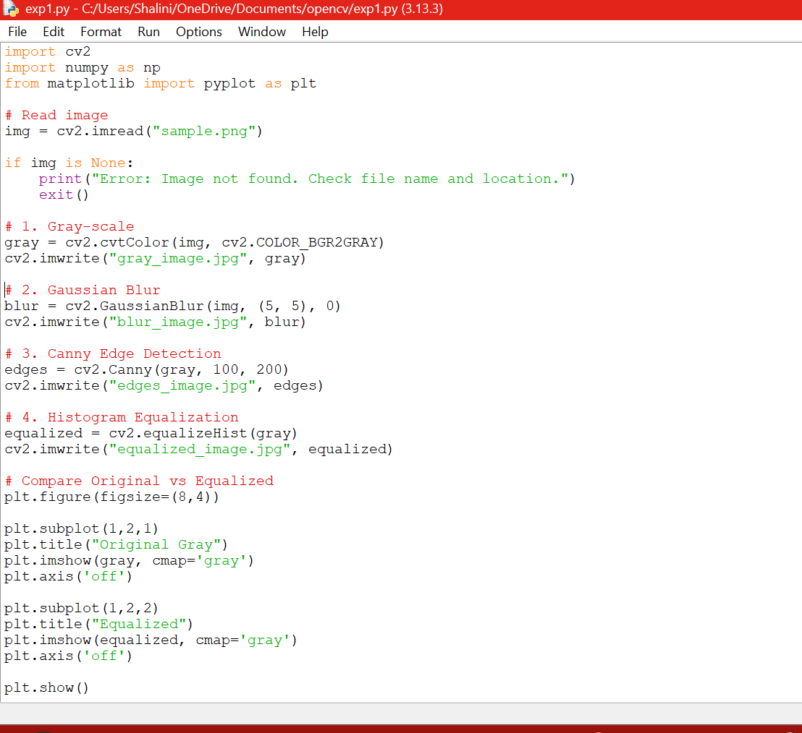
OUTPUT:
